**R-Lab 3 – Reading Data in R**If you have a single variable data (with small size), you can type in R console to create a R data set. However in real life, we work data contains many variables and observations. These data can be in different formats e.g. **.txt, .csv**. These are external data file you need to read in R to create R data file to work.

**### Reading .csv data file into R**# Function

**read.csv**():

# Basic format   
read.csv(external data file, header = TRUE, sep = ",", **...**)

Here,   
header=TRUE: To read first row for the data that contains variables name (known as header)  
sep = “,”: in .csv data, the separator between the data value is comma.  
  
**Your Task:**

1. First download and save “**Data file:** mpg.csv” file from the blackboard to your computer  
2. Download the data description file also and read it to understand about the data.  
3. Read **mpg.csv** file into R and create a R data file **mpgd**.

> mpgd = read.csv("C:/Users/dbhatta/Desktop/mpg.csv", header=T, sep= ",")

# Print your data

> mpgd

## Learn: variable names  
  
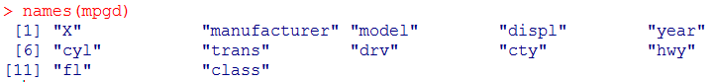

# Number of data rows and variable columns  
 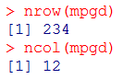

# Print first row of the data  
  


# Print first 10 rows of the data 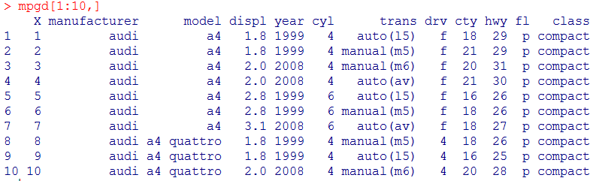# Print a data value located at row = 2, col = 3



# Print column = 4

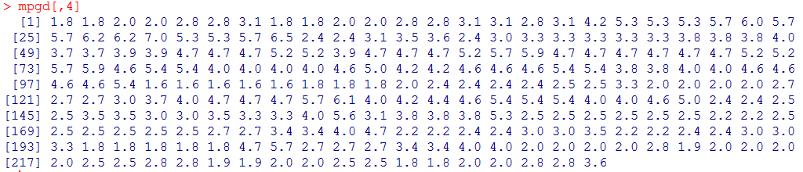

**# If you try to construct the frequency distribution of variable “manufacturer” as:**  
  
  
This means R did not recognize the variable. To fix this problem, there are various ways.  
 **1. Use column name instead of variable name. Variable manufacturer is in column = 2**

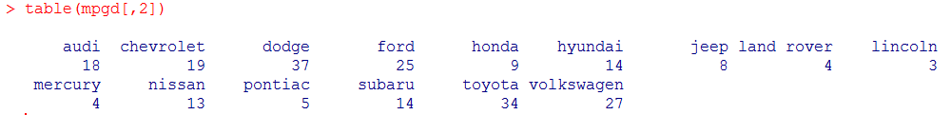

**2. Write a variable name after data name followed by dollar sign ($)**  
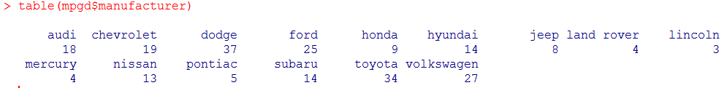

**2. Use R function “attach()”**  
**attach():** The database is attached to the **R** search path. This means that the database is searched by **R** when evaluating a variable, so objects in the database can be accessed by simply giving their names.

**Usage**

attach(what, pos = 2L, name = deparse(substitute(what), backtick=FALSE),

warn.conflicts = TRUE)

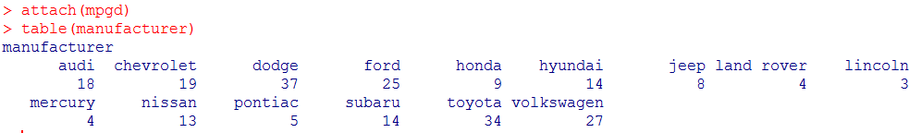

**# If you want to detach :**  
> detach(mpgd)

> table(manufacturer)

Error in table(manufacturer) : object 'manufacturer' not found